**Type Casting In Java**

We often encounter situations where there is a need to store a value of one type into a variable of another type. Assigning a value of one type to a variable of another type is known as **type casting.**

Type castings are of two types.

* **Implicit Casting(Widening Casting)**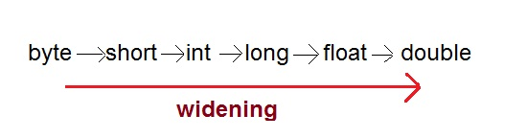

It generally takes place when-

* The two types are compatiable
* The target type is larger than the source type(i.e. the destination type has enough precision to store the source value)
* Automatically done by the compiler
* **Explicit Casting(Narrowing casting)**

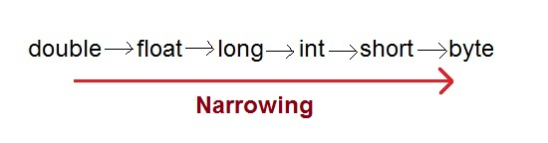

* The target type is smaller than the source type.
* Have to mention explicitly.

Have to follow the following syntax for explicit type casting:-

Type variable1= (type) variable2;